I. True or False
- The use of a Visited list enhances the performance of Uniform Cost search without affecting its correctness.
- The Dynamic Programming optimality principle says that all we ever need is to find the single shortest path to any state; any other paths can never be part of the best path from the start to the goal.
- The use of an Expanded list enhances the performance of Uniform Cost search without affecting its correctness.
- Uniform Cost (without an Expanded list) looks at every possible path to the goal so that it can be sure it has found the best one.
- Admissible heuristics for path searching always use straight-line distance to the goal.
- A* will generally be more efficient than Uniform Cost search since, in the worst case, an admissible heuristic gives no additional help but it never hurts.
- To guarantee that A* finds optimal paths (when using a strict Expanded list) we must use a consistent heuristic function (as defined in the notes).
II. A*
Consider the directed graph shown below with start state S and goal state G. The figure shows the heuristic values at each state, i.e., the estimates of the length of a path from that state to the goal.
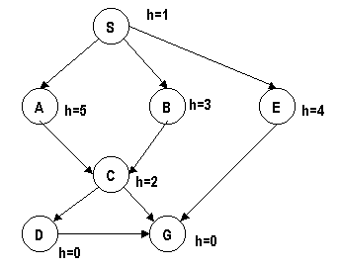
Unfortunately we do not know the link costs (lengths), and we really would like to know them. However and fortunately:
- We know that the given heuristic is admissible.
- There is a record of the expansion produced by A*, as listed below, where each list represents the A* evaluation of each path followed by the states in the path.
- We assume here that Q is kept sorted by the value of the search nodes.
- There is no Expanded list in use, but after adding a new node to Q, we go through and discard any node where a shorter path to the corresponding state exists in Q.
Step | Path expanded | Paths Added to Q | Sorted Resulting Q
1. | (1 S) | (6 A S) (5 B S) (8 E S) | (5 B S) (6 A S) (8 E S)
2. | (5 B S) | (7 C B S) | (6 A S) (7 C B S) (8 E S)
3. | (6 A S) | (6 C A S) | (6 C A S) (8 E S)
4. | (6 C A S) | (5 D C A S) (10 G C A S) | (5 D C A S) (8 E S) (10 G C A S)
5. | (5 D C A S) | (8 G D C A S) | (8 E S) (8 G D C A S)
6. | (8 E S) | (12 G E S) | (8 G D C A S)
7. | (8 G D C A S) | -- | --
- Fill in the link costs on the graph for all the connecting links.
Hint 0: Note that each path added to Q will let you fill in the cost of exactly one link in the graph.
S-A 
S-B
S-E
A-C
B-C
C-D
C-G
D-G
E-G

- Why was the path (7 C B S) removed from the resulting sorted Q at step 3?
  - No answer
  - It forms a loop
  - There are no descendants of C
  - A shorter path to C was found.
  - C is on the Visited List
  - C is on the Expanded List

- Why couldn't A* finish its search at steps 4 or 5?
  - No answer
  - No path has reached the goal
  - The paths to the goal are not unambiguously the best ones in Q
  - There exists an unambiguously better path in Q

- A friend of yours claims that: In general, if we are given an arbitrary search problem, such that:
  - We know that the given heuristic estimate is admissible (the actual distance is greater that the value of the heuristic estimate).
  - There is a record of the complete A* search episode, like that in the table above.
Then, the costs of all the links in this arbitrary search problem can be uniquely determined.

You think your friend is wrong. To convince him, assign the link costs in the following simple graph (the search is from S to G) to provide a counterexample:
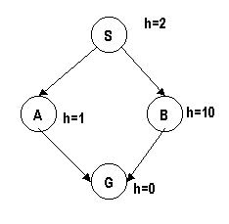
Enter your answer as a sequence of four numbers for the link costs of S-A, A-G, S-B, and B-G (in that order): Many answers are possible so we will only show you one answer as "the correct answer", but we will accept any combination that proves the point.

